Annotation Assignment

Section1: Create a custom annotation called @Test which can be only applied on a method implying that the following method is a test-case .(Is it possible to restrict the annotation to be applied only on a non-static method?)

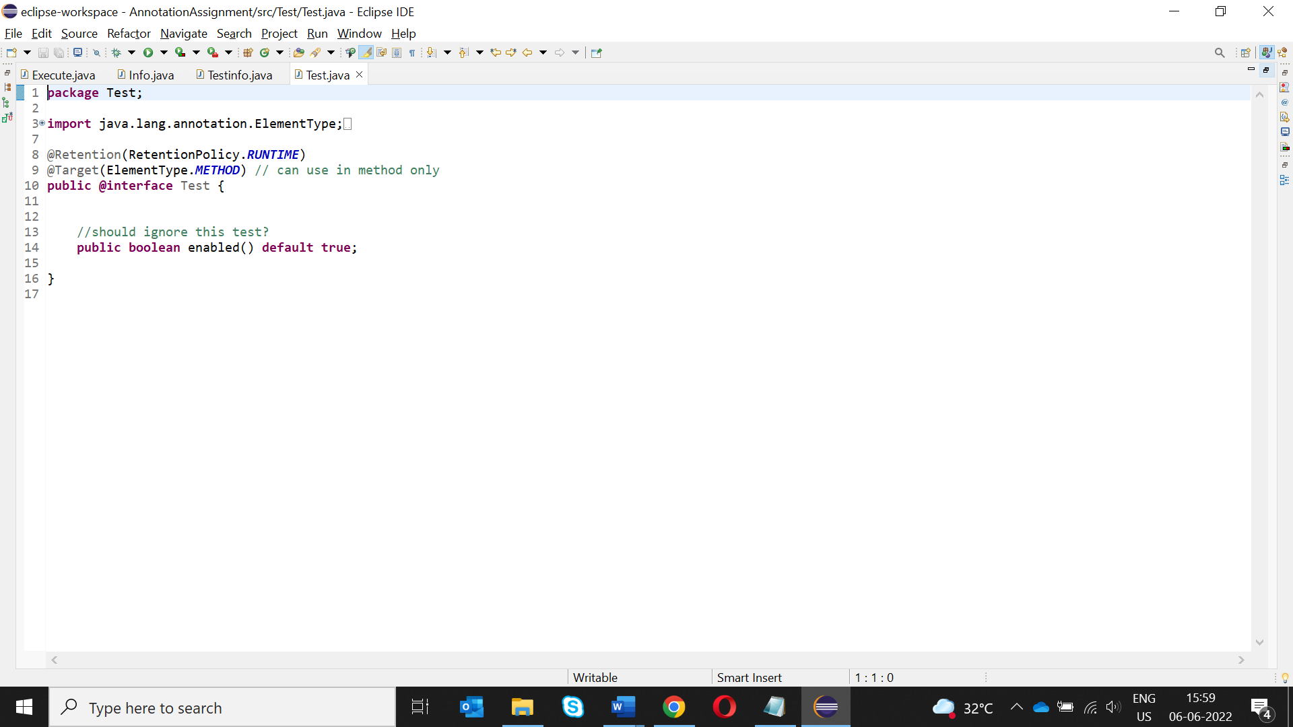

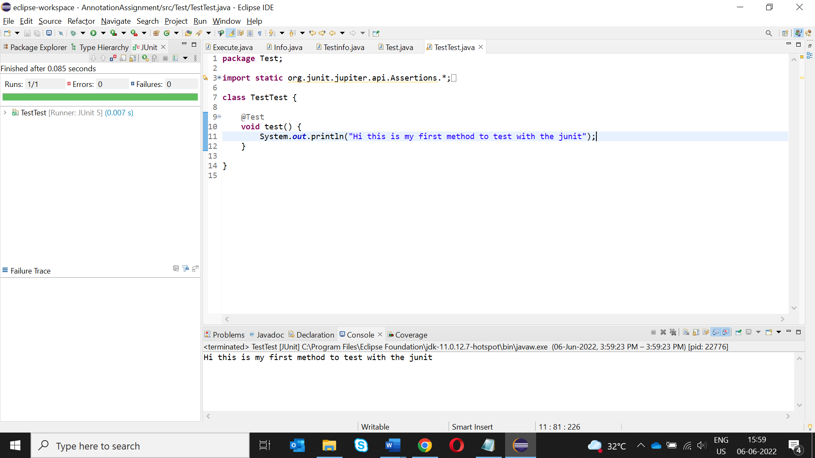

Section2: Build a custom annotation called @Info ,which can be used by developers on a class ,a property,or a method. The developer can provide the following information when using this annotation:

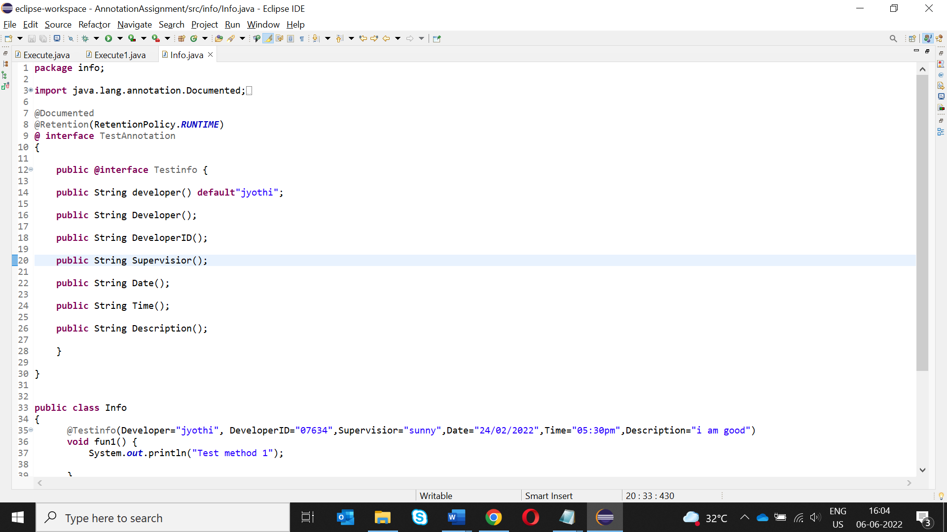

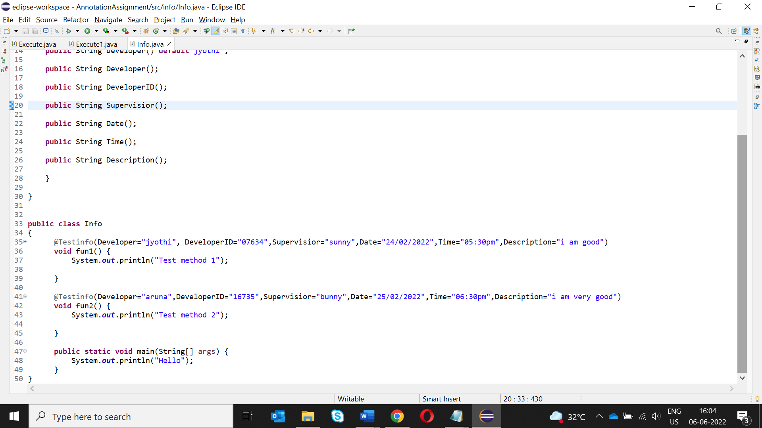

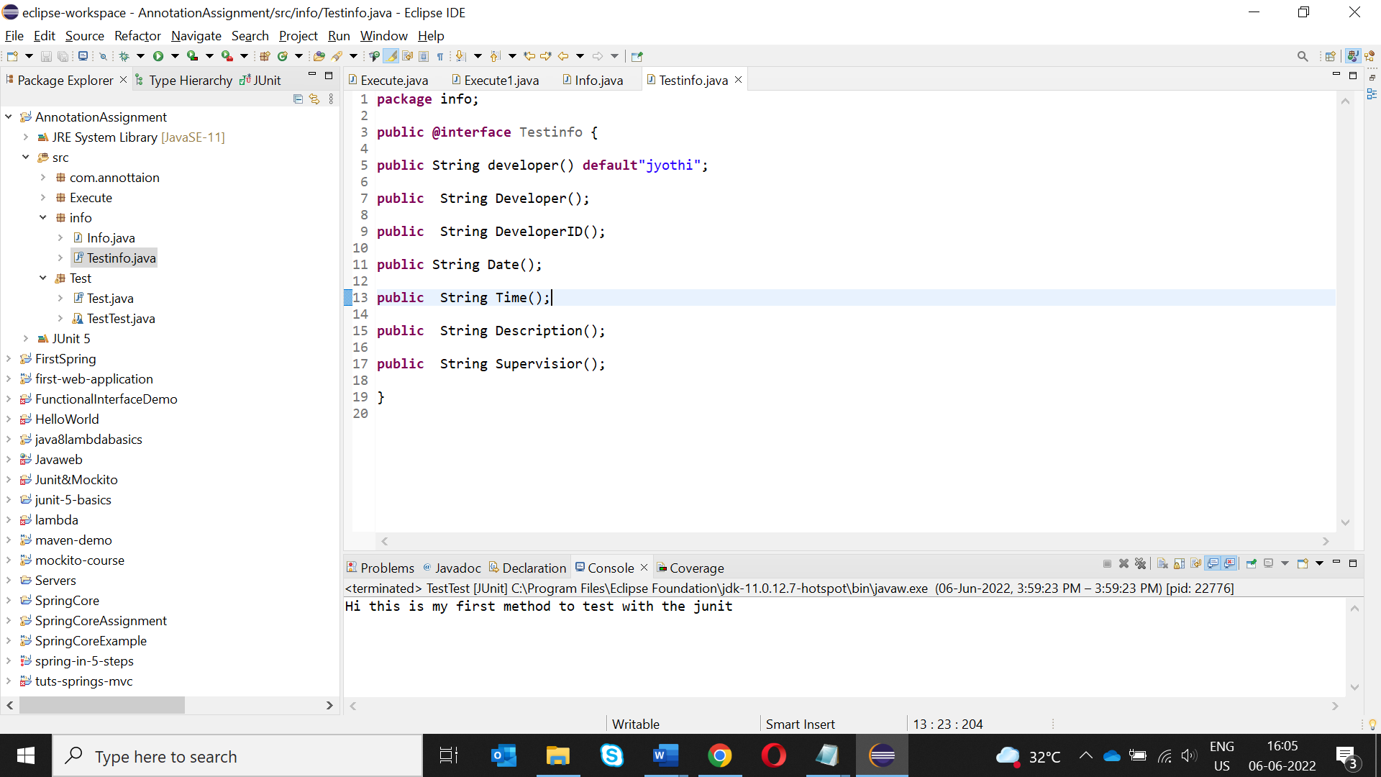

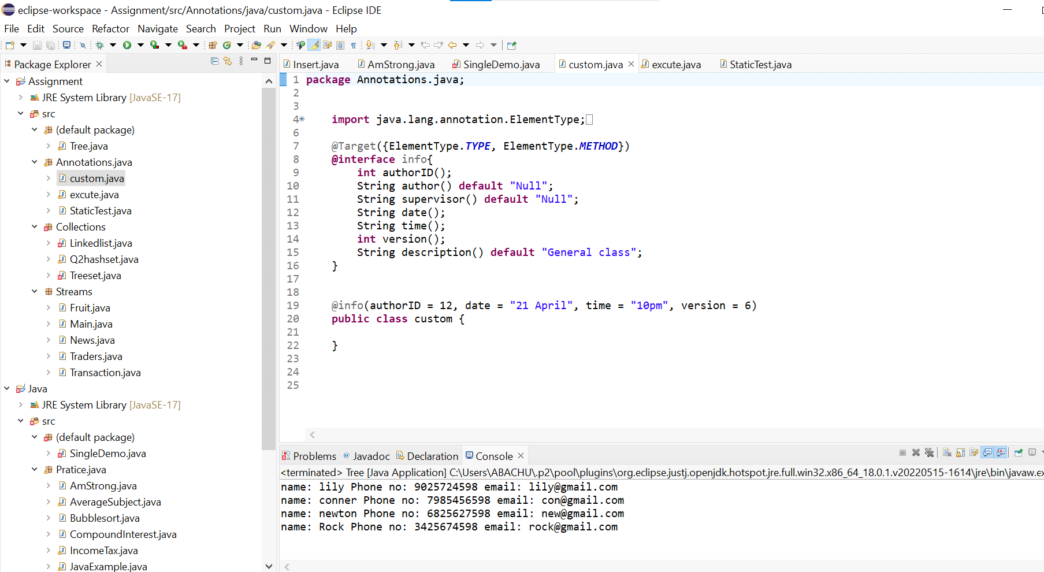

Section3: Create a custom annotation called @Execute to be applied on methods .Placing the @Execute method on a method implies that methods should be invoked using Reflection API.

